Besides examining how tourists change their interest regarding to type of rooms, we also want to examine that whether tourists now prefer to rent property outside of the metropolitan because of the pandemic.

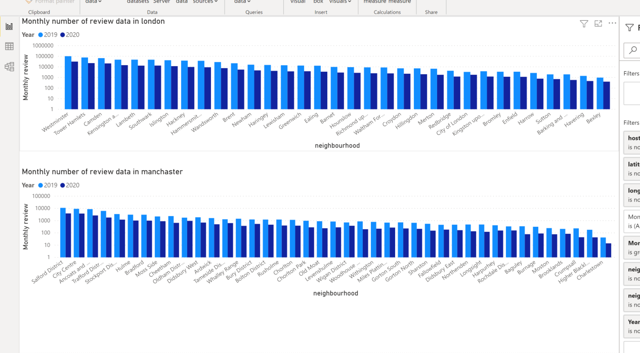We first draw bar graph to examine that how the total number of review data within the same months have dropped from 2019 for every neighborhood in both London and Greater Manchester. However, by merely drawing bar graph, we fail to visualize the relationship between the drop of total number of reviews for neighborhood and its corresponding distance to the metropolitan region.

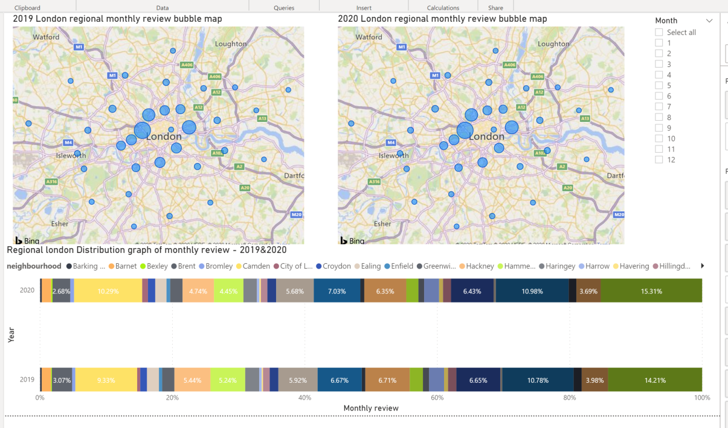

Therefore, we visualized the drop of total number of reviews in 2019 and 2020 on maps for comparison. Take London for example, the larger the circle, the bigger the drop of total number of reviews. However, the size of the circle of 2019 and 2020 are quite close and we cannot really tell the difference. Besides, we failed to consider that the popularity of different neighborhood is different before pandemic. Therefore, we could not draw any conclusion to our hypothesis by merely considering the number of dropping.

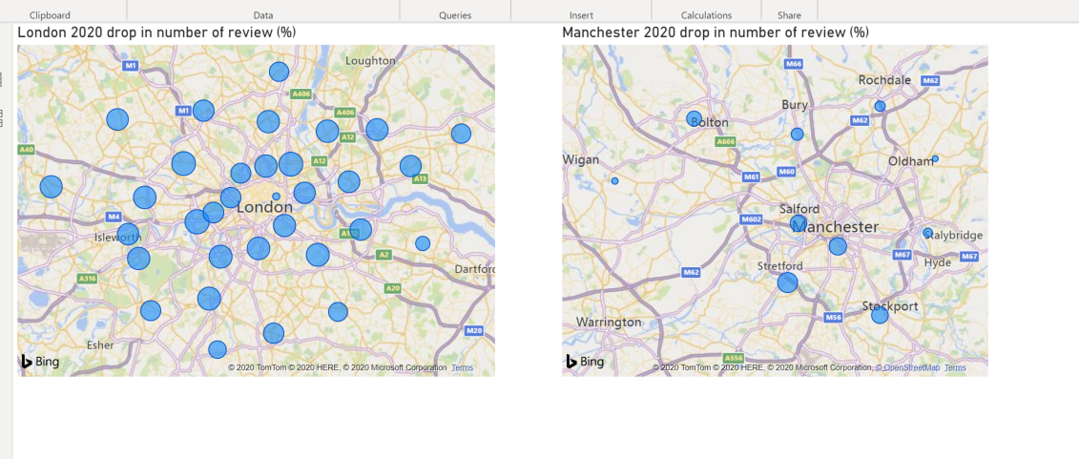

Eventually, we visualized the drop in number of reviews from the data in 2019 in percentage for both London and Greater Manchester. Again, the larger the circle, the bigger the drop in percentage. How the pandemic shaped tourists’ interest in metropolitan is more obvious in the map of Manchester than in London. From the map of Great Manchester, it is obvious that the drop of total number of reviews in neighborhood that is far away from city center is smaller than the drop of total number of reviews in neighborhood that is close to city center.

The similar trend could be observed in the map of London but much less obvious. Part of the reason might be that most neighborhood in London is metropolitan where population density is high.